
X0303

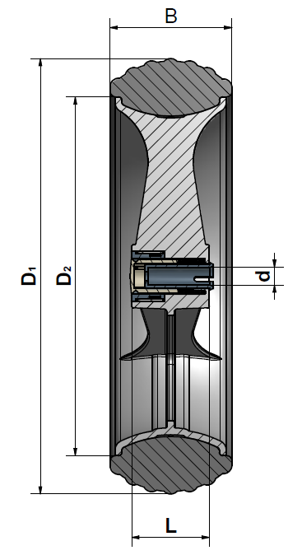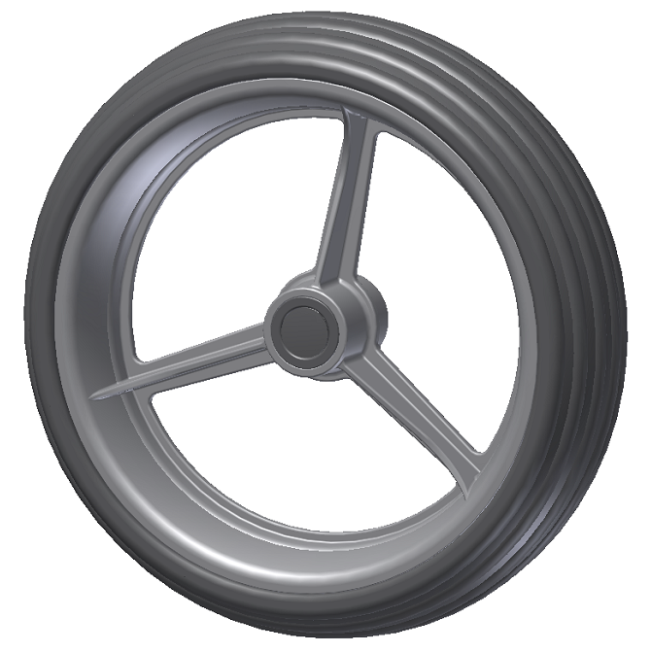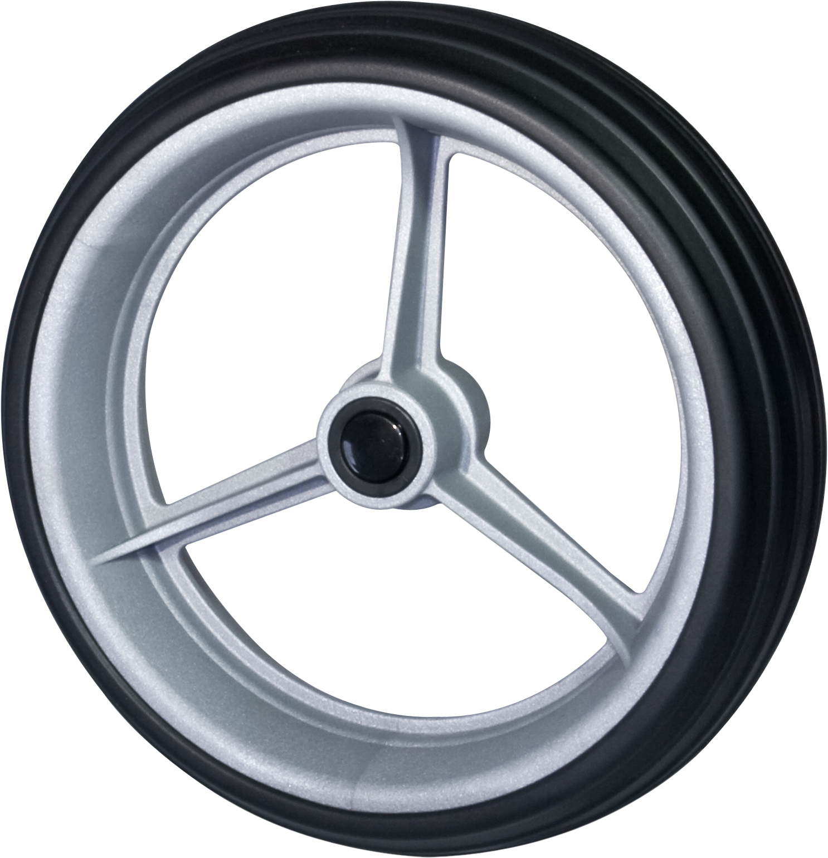

Art. No. | 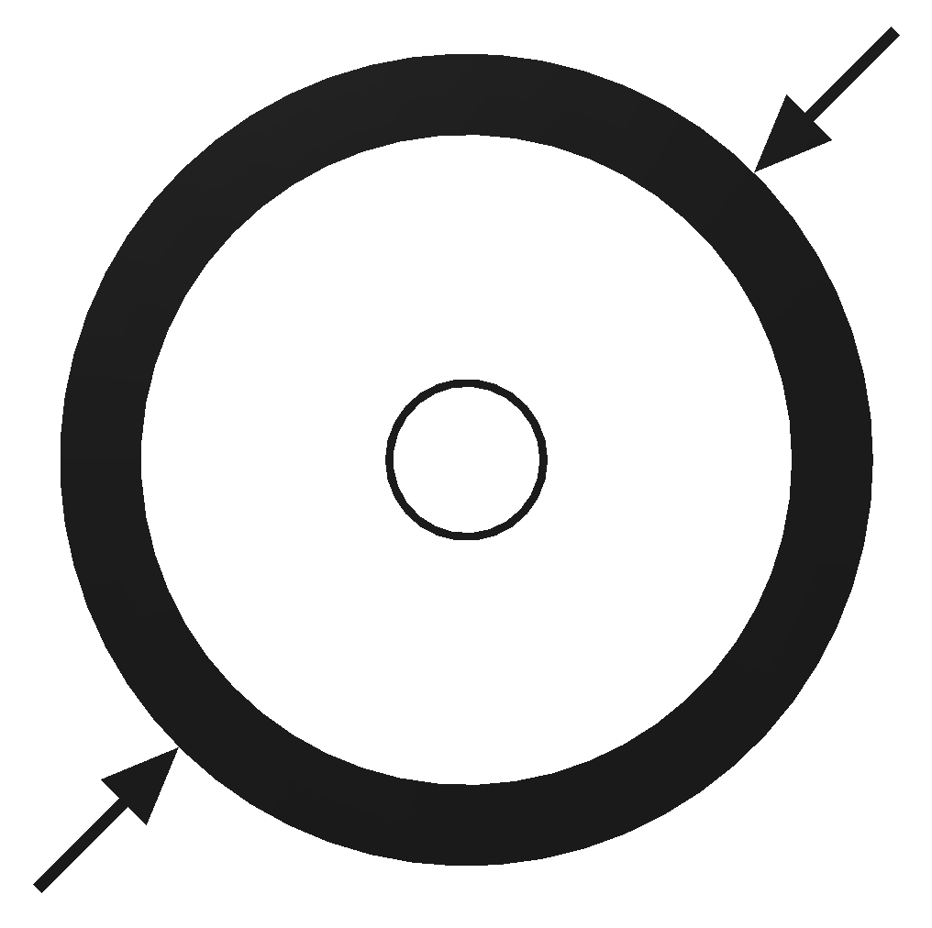 | 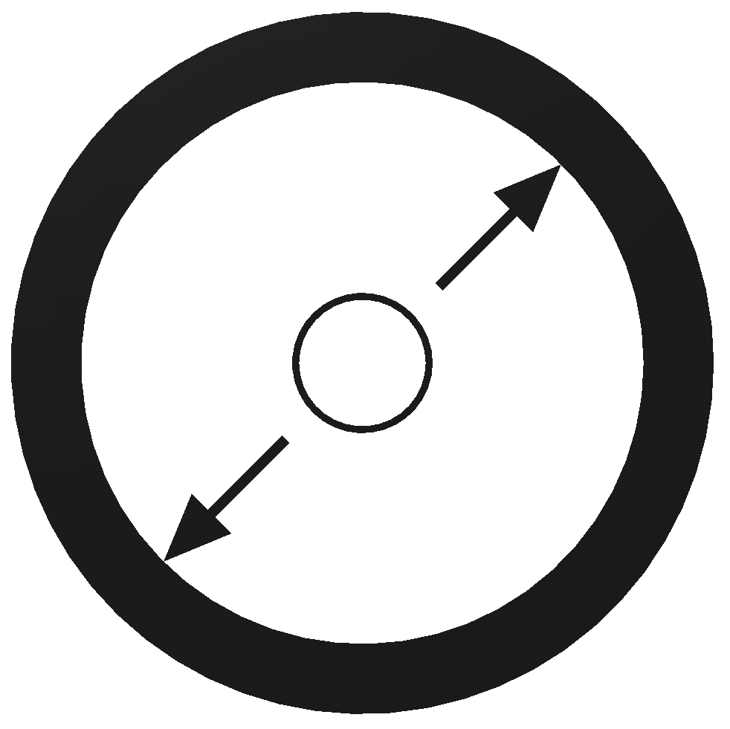 | 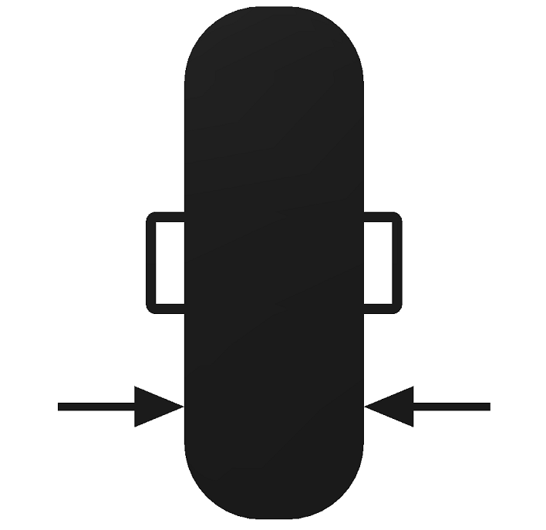 | 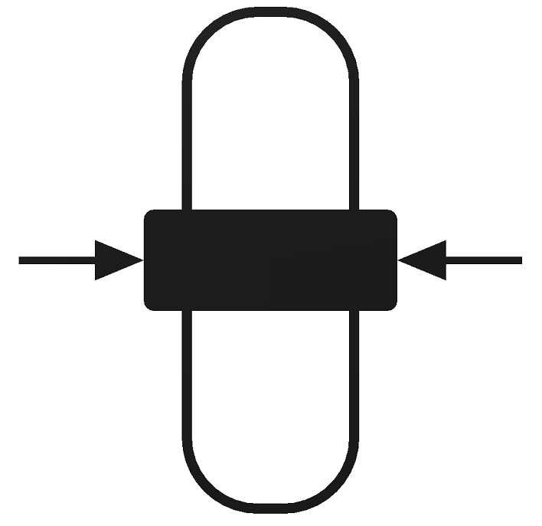 |  | Tyre tread | Fastener | 
Art. No. | Diameter  D1 | Diameter  D2 | Tyre width  B | Hub length  L | Axial dimension  d |  |  | Load  capacity
X0303-155/195/67 | 195 mm | 155 mm | 67 mm | 45 mm | 10 mm | lengthwise grooved | push button | 50 kg
X0303-210/250/67 | 250 mm | 210 mm | 67 mm | 45 mm | 10 mm | lengthwise grooved | push button | 50 kg
X0303-275/315/67 | 315 mm | 275 mm | 67 mm | 45 mm | 10 mm | lengthwise grooved | push button | 50 kg

Colour - rim: silver or black (standard), special colours on request.
Colour - tyre: black (standard), special colours on request.
Colour - fastener: black or silver (standard), special colours on request.

Material - rim: PA (15% respectively 30% glas fiber)
Material - tyre: EVA
Material - fastener: PA 6.6

Alternative tyre treads on request.

Alternative fasteners on request.

